Group 4’s Model Activity Diagrams and State Machine Diagrams ADAV System Final Report

Behavioral Report – Activity Diagrams and State Machine Diagrams

Author: Men at Work: Maxwell Polley, Ryan Patton, William Symolon, Joseph Mitchell

Revision: 0.1

|  |  |
| --- | --- |
| No Magic |  |
| One Allen Center, 700 Central Expressway South, Suite 110 Allen, Texas 75013 USA | Date: May 03, 2020 |

**Revision History**

|  |  |  |  |
| --- | --- | --- | --- |
| **Revision** | **Date** | **Reason For Changes** | **Author** |
| 0.1 | 05/03/2020 | Behavioral Report – Activity Diagrams and State Machine Diagrams Initial Draft | Men at Work |

**Table of Contents**

Introduction 1

Purpose 1

Scope 1

Overview 1

ADAV System::Behavioral Diagrams::Activity Diagrams 2

ADAV Maintenance 2

Deploy ADAV 3

Deploy ADAV on a C-17 4

Deploy ADAV on land using LCH 5

LHC Soldier Infiltration Along Beach 6

Load ADAV onto LHD Ship for Sea Deployment 7

Operate ADAV for Training Purposes 8

ADAV System::Behavioral Diagrams::State Machine Diagrams 9

ADAV System 9

Destroy 10

Climate Control 11

Deployability 12

Mobility 13

Security 14

Survivability 15

**Table of Figures**

Figure 1. ADAV Maintenance 2

Figure 2. Deploy ADAV 3

Figure 3. Deploy ADAV on a C-17 4

Figure 4. Deploy ADAV on land using LCH 5

Figure 5. LHC Soldier Infiltration Along Beach 6

Figure 6. Load ADAV onto LHD Ship for Sea Deployment 7

Figure 7. Operate ADAV for Training Purposes 8

Figure 8. ADAV System 9

Figure 9. Destroy 10

Figure 10. Climate Control 11

Figure 11. Deployability 12

Figure 12. Mobility 13

Figure 13. Security 14

Figure 14. Survivability 15

# Introduction

## Purpose

This document provides an overview of the activity diagrams and state machine diagrams associated with the ADAV model.

## Scope

The Air Deliverable Amphibious Vehicle (ADAV) advances military personnel capabilities around rivers, estuaries, and littoral environments. The activity diagrams presented within detail the activities undertaken by the ADAV within its functional operations. The state machine diagrams presented within represent the different states the ADAV undergoes within its functional operations.

## Overview

This document presents 7 activity diagrams and 7 state machine diagrams. The 7 activity diagrams overview the 7 scenarios detailed in the Project Proposal. The 7 state machine diagrams represent a comprehensive overview the ADAV undergoes during its operations, relating back to cover the ADAV’s requirements.

# ADAV System::Behavioral Diagrams::Activity Diagrams

## ADAV Maintenance

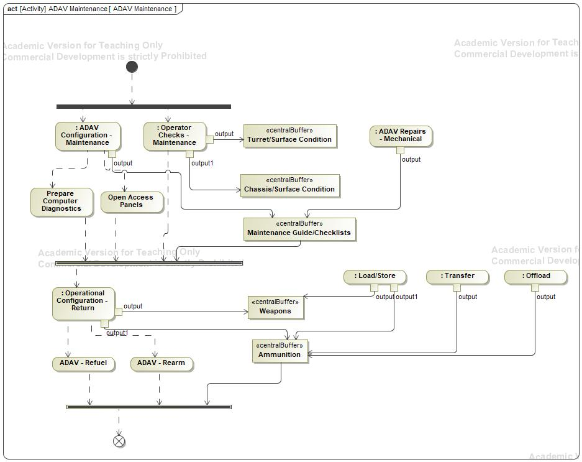

1. ADAV Maintenance

## Description

The ADAV Maintenance activity diagram seen in Figure 1 shows the process by which the ADAV can be maintained and fixed during battlefield operations.

## Deploy ADAV

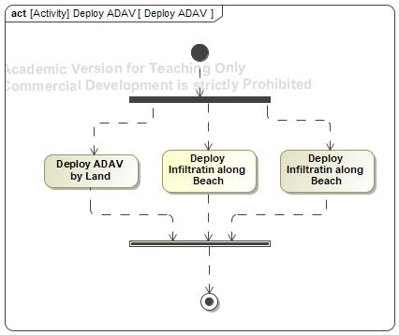

1. Deploy ADAV

## Description

The Description activity diagram seen in Figure 2 shows the deployment options for the ADAV.

## Deploy ADAV on a C-17

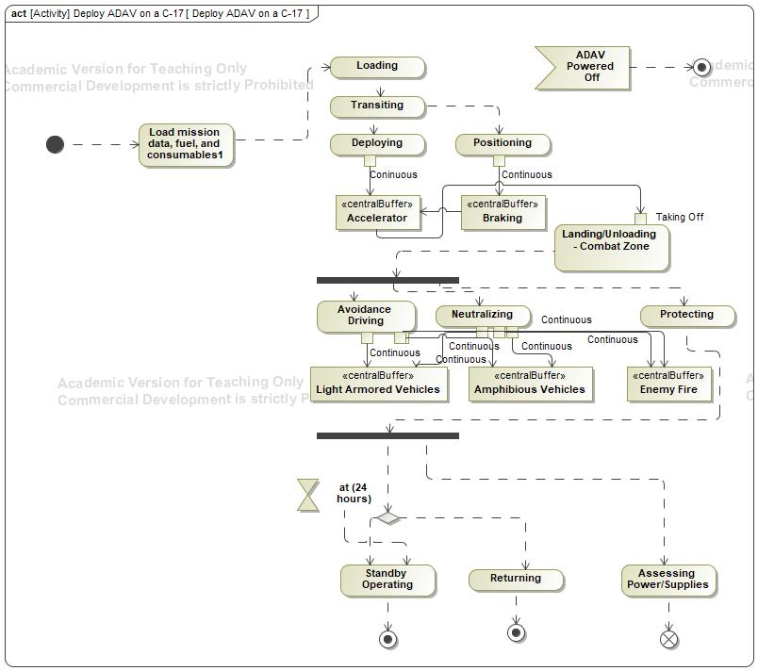

1. Deploy ADAV on a C-17

## Description

The Deploy ADAV on a C-17 activity diagram seen in Figure 3 shows the process by which the ADAV would deploy from the C-17 and enter battlefield operations.

## Deploy ADAV on land using LCH

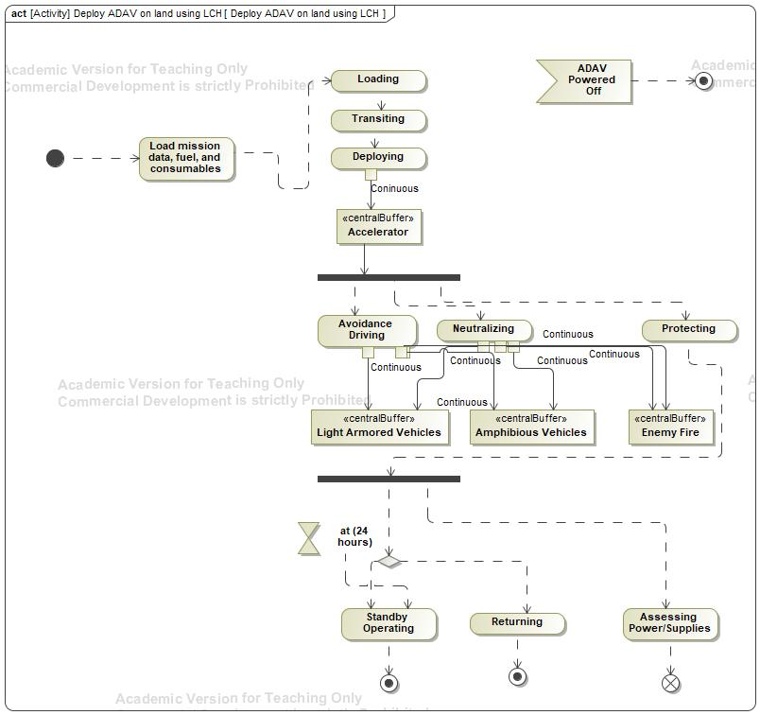

1. Deploy ADAV on land using LCH

## Description

The Deploy ADAV on land using LCH activity diagram seen in Figure 4 shows the process by which the ADAV would deploy from the LCH and enter battlefield operations.

## LHC Soldier Infiltration Along Beach

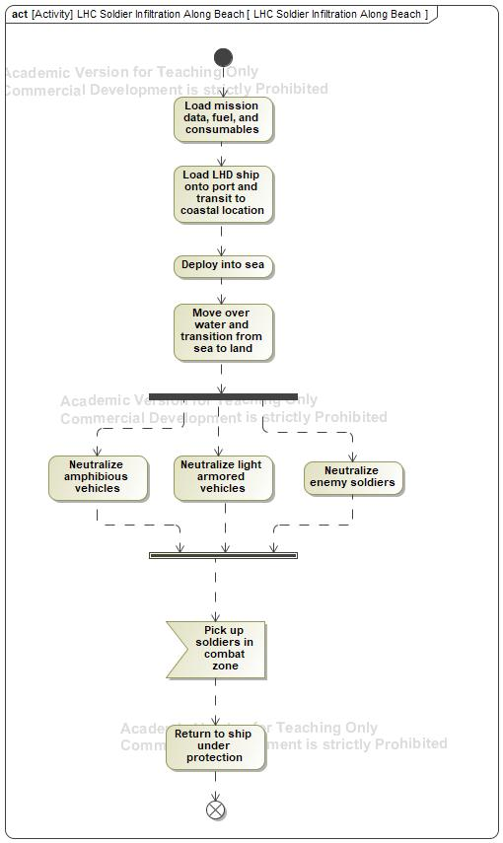

1. LCH Soldier Infiltration Along Beach

## Description

The LCH Soldier Infiltration Along Beach activity diagram seen in Figure 5 shows the process by which the ADAV supports soldier battlefield operations along the beach.

## Load ADAV onto LHD Ship for Sea Deployment

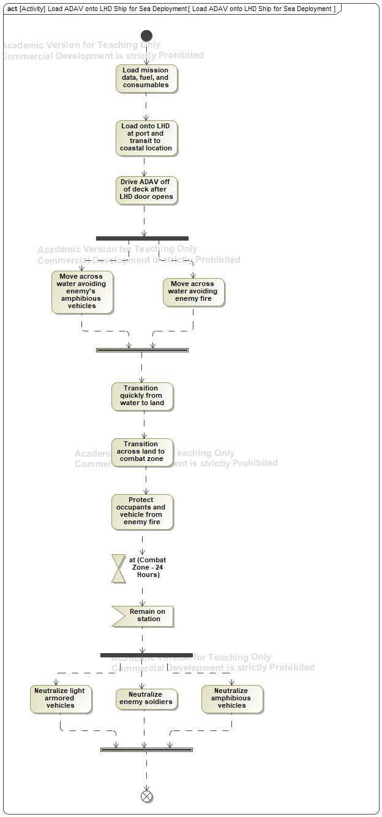

1. Load ADAV onto LHD Ship for Sea Deployment

## Description

The Load ADAV onto LHD Ship for Sea Deployment activity diagram seen in Figure 6 shows the process by which the ADAV is loaded onto the ship and enters battlefield operations.

## Operate ADAV for Training Purposes

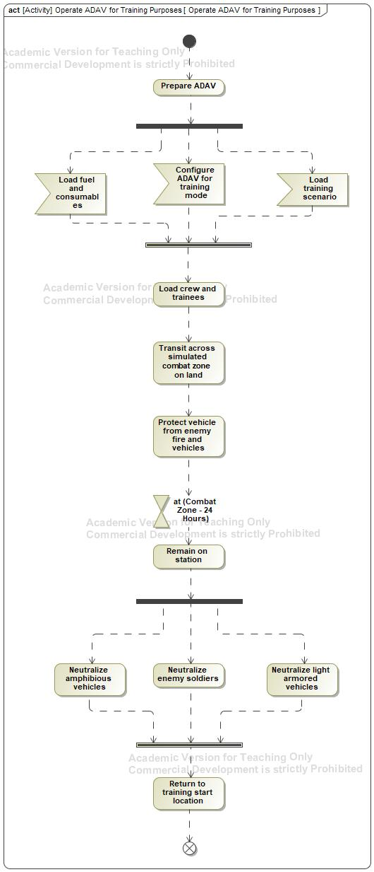

1. Operate ADAV for Training Purposes

## Description

The Operate ADAV for Training Purposes activity diagram seen in Figure 7 shows the process by which the ADAV can simulate battlefield operations for training purposes.

# ADAV System::Behavioral Diagrams::State Machine Diagrams

## ADAV System

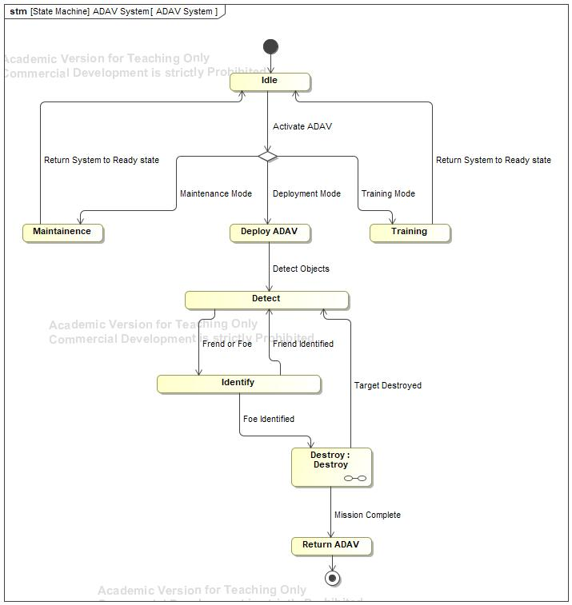

1. ADAV System

## Description

The ADAV System state machine diagram seen in Figure 8 shows the states the ADAV enters during its operational scenarios.

## Destroy

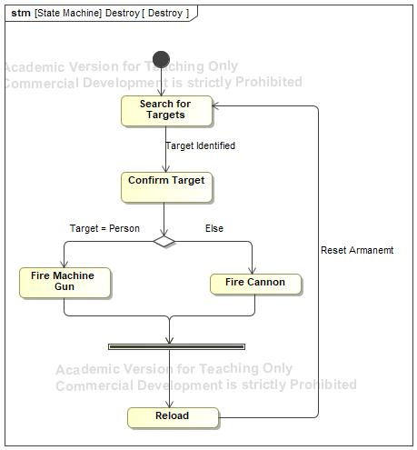

1. Destroy

## Description

The Destroy state machine diagram seen in Figure 9 shows the states the ADAV enters during lethality operations against the enemy.

## Climate Control

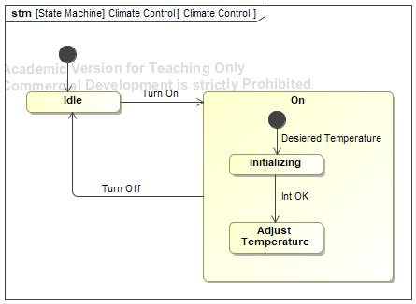

1. Climate Control

## Description

The Climate Control state machine diagram seen in Figure 10 shows the ADAV cabin temperature control process during operations.

## Deployability

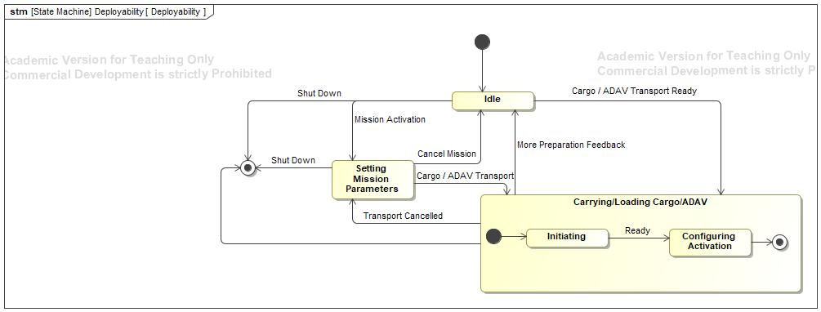

1. Deployability

## Description

The Deployability state machine diagram seen in Figure 11 shows the states the ADAV enters during mission deployment operations.

## Mobility

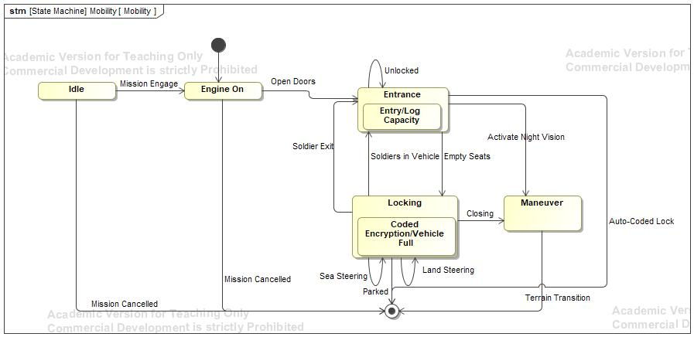

1. Mobility

## Description

The Mobility state machine diagram seen in Figure 12 shows the states the ADAV enters for transportation during battlefield operations.

## Security

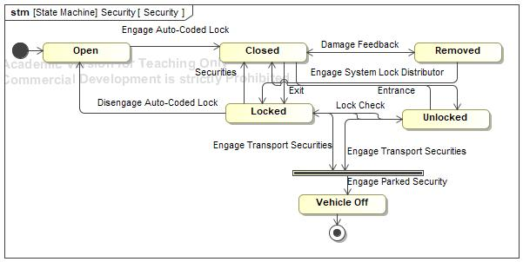

1. Security

## Description

The Security state machine diagram seen in Figure 13 shows the states the ADAV enters to securely arm and lock the vehicle during operations.

## Survivability

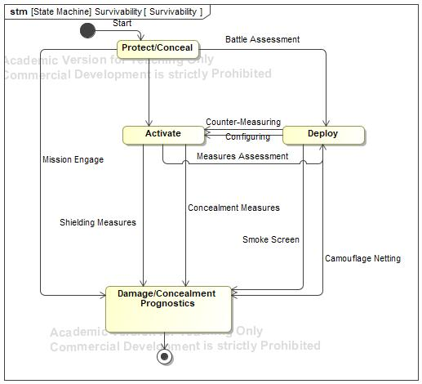

1. Survivability

## Description

The Survivability state machine diagram seen in Figure 14 shows the states the ADAV enters for survivability measures during operations, such as concealment and protection.